**DAILY ONLINE ACTIVITIES SUMMARY**

|  |  |  |  |  |  |  |  |  |
| --- | --- | --- | --- | --- | --- | --- | --- | --- |
| **Date:** | **1-06-2020** | | | | | **Name:** | **Pavana P** | |
| **Sem & Sec** | **6A** | | | | | **USN:** | **4AL17CS057** | |
| **Online Test Summary** | | | | | | | | |
| **Subject** | | **CNSC** | | | | | | |
| **Max. Marks** | | **60** | | **Score** | | | **44** | |
| **Certification Course Summary** | | | | | | | | |
| **Course** | **Introduction to Cloud.** | | | | | | | |
| **Certificate Provider** | | | Cognitive classes | | **Duration** | | | 7 hours |
| **Coding Challenges** | | | | | | | | |
| **Problem Statement:**   1. Python Program to remove duplicate elements from a list   2.Write a Java Program to left rotate the elements of an array  **3.Given an array of positive integers. Write a C Program to find the leaders in the array.** | | | | | | | | |
| **Status: Completed** | | | | | | | | |
| **Uploaded the report in Github** | | | | | **YES** | | | |
| **If yes Repository name** | | | | | **DAILY STATUS** | | | |
| **Uploaded the report in slack** | | | | | **YES** | | | |

.

**Online Test :**

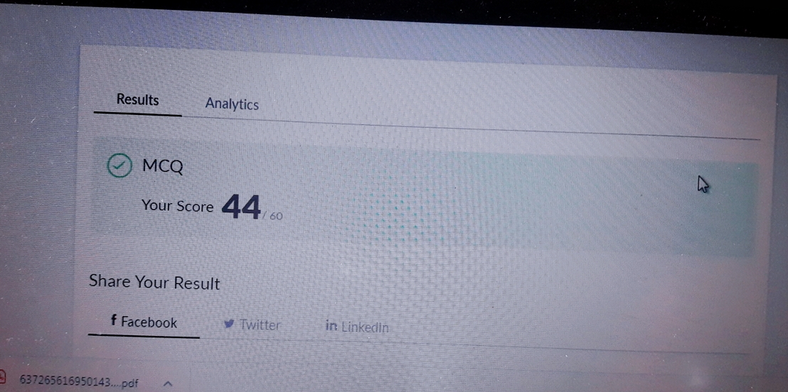Subject:-CNSC

**Certification Course Details:**

**Introduction to Cloud:**

Today I have completed these topics:

1.Cloud computing service and Deployment Models .

2.Components of Cloud Computing.

.

.

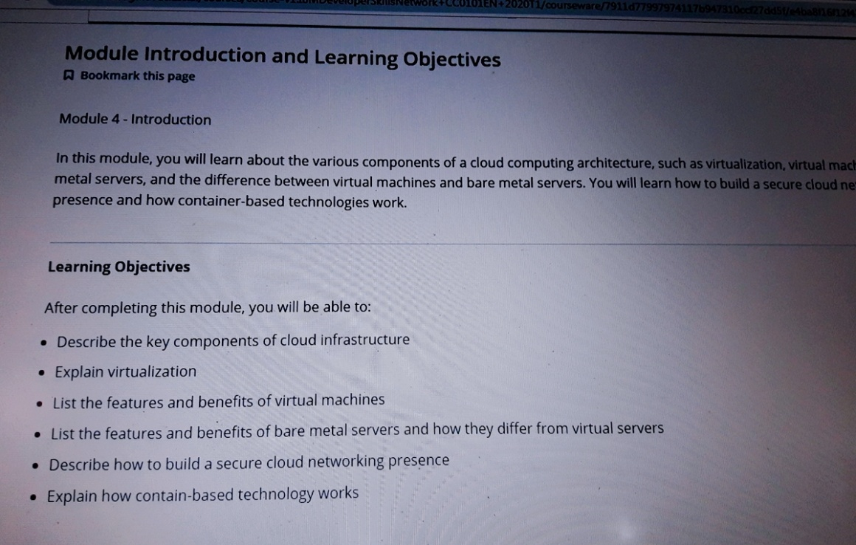

**Coding Challenges Details:**

**https://github.com/pavana-p-kulal/DAILY-STATUS/tree/master/1-6-20/Online%20Coding**